LAB TASK-6(24k-0555)

Question :1

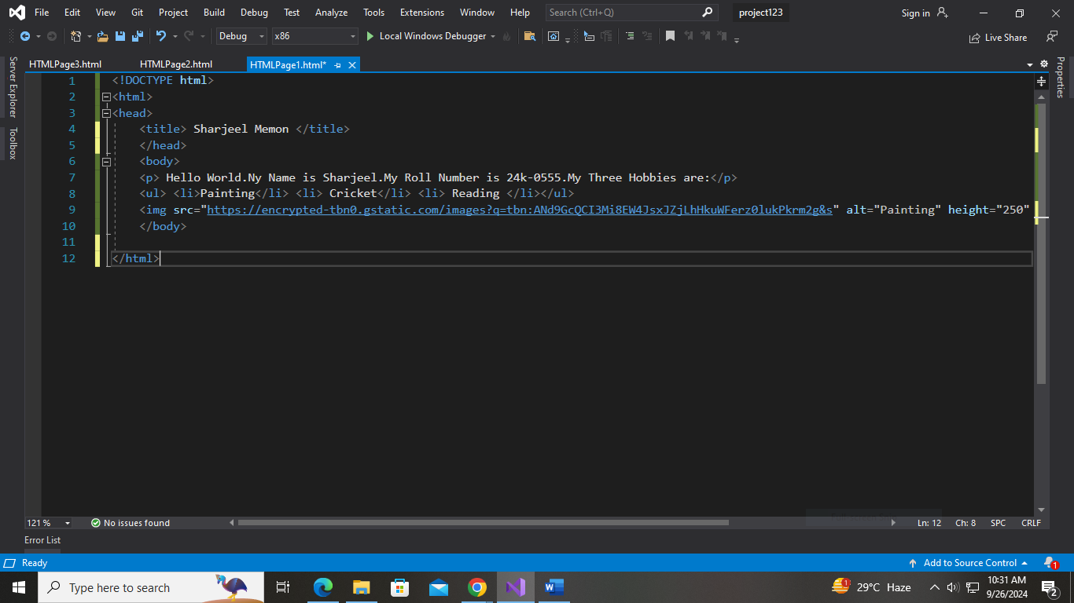

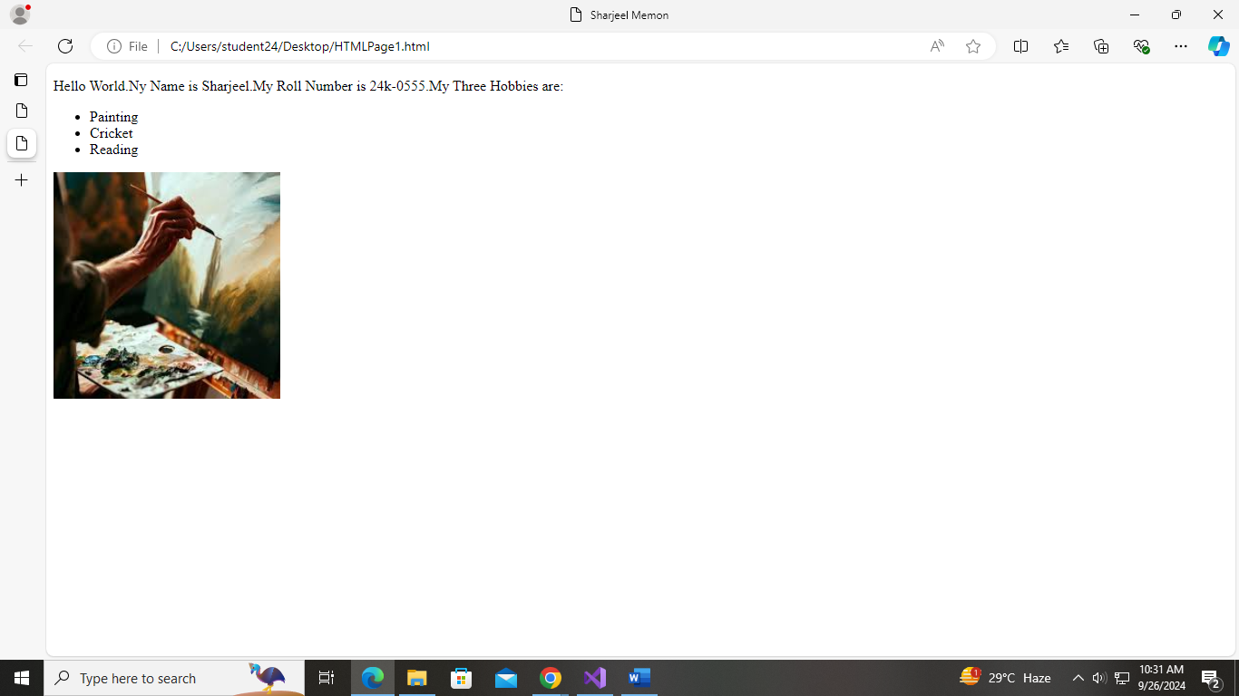

<!DOCTYPE html>

<html>

<head>

<title> Sharjeel Memon </title>

</head>

<body>

<p> Hello World.My Name is Sharjeel.My Roll Number is 24k-0555.My Three Hobbies are:</p>

<ul>

<li>Painting</li>

<li> Cricket</li>

<li> Reading </li>

</ul>

<img src="https://encrypted-tbn0.gstatic.com/images?q=tbn:ANd9GcQCI3Mi8EW4JsxJZjLhHkuWFerz0lukPkrm2g&s" alt="Painting" height="250" width="250" />

</body>

</html>

Question :2

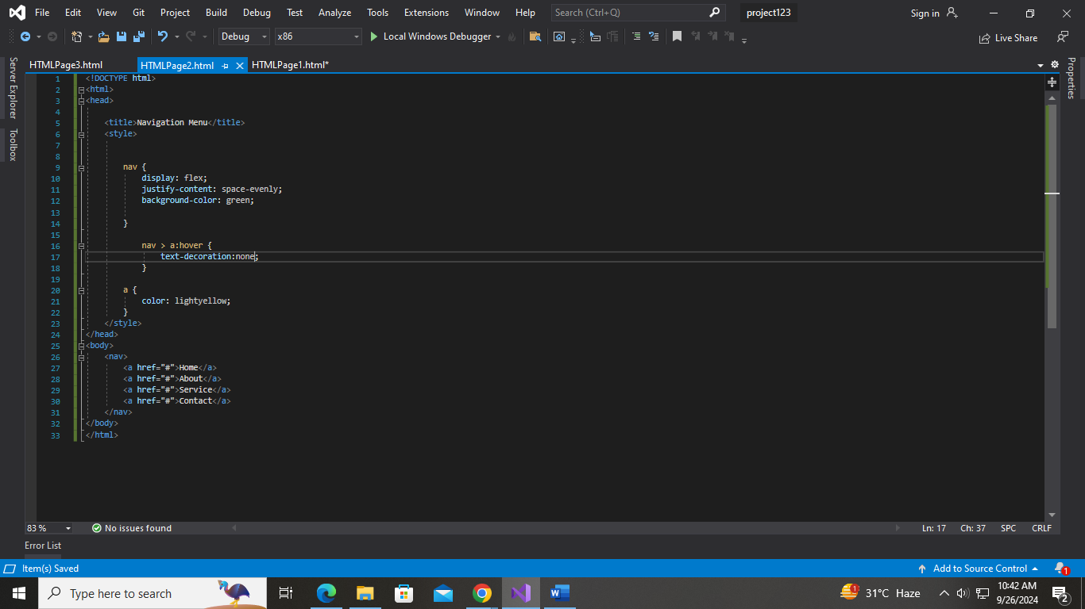

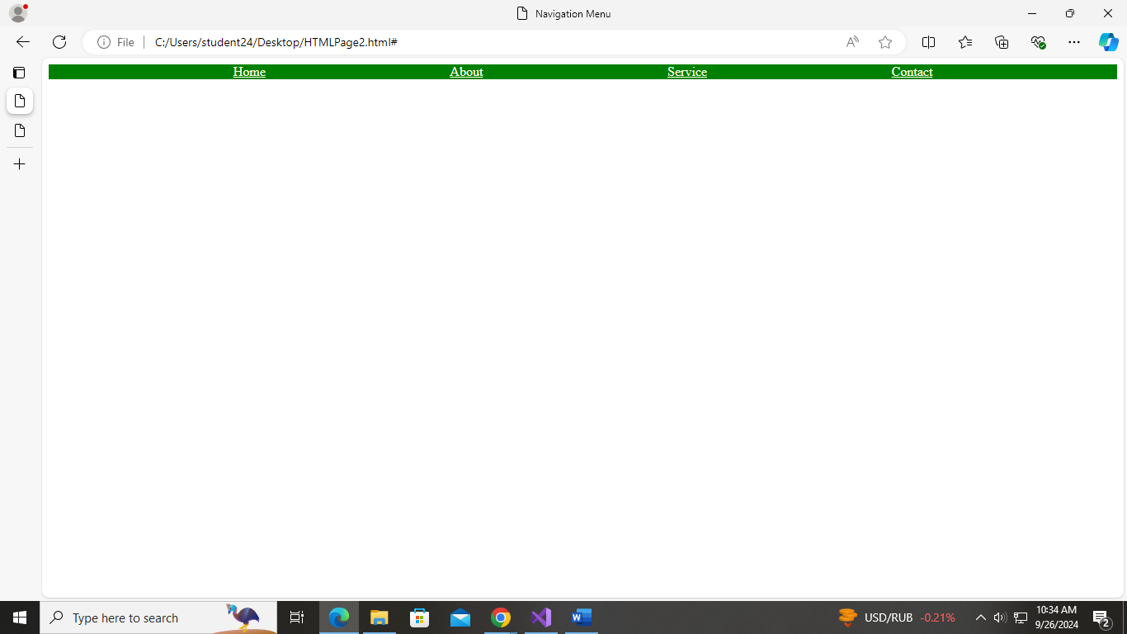

<!DOCTYPE html>

<html>

<head>

<title>Navigation Menu</title>

<style>

nav {

display: flex;

justify-content: space-evenly;

background-color: green;

}

nav > a:hover {

text-decoration: center;

}

a {

color: lightyellow;

}

</style>

</head>

<body>

<nav>

<a href="#">Home</a>

<a href="#">About</a>

<a href="#">Service</a>

<a href="#">Contact</a>

</nav>

</body>

</html>

Question 3:

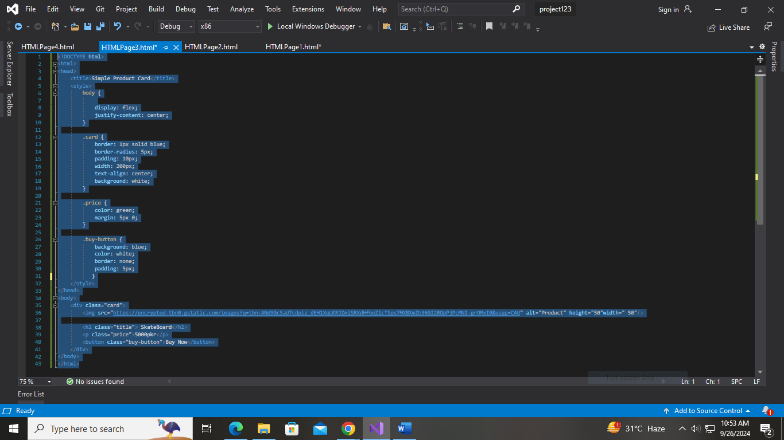

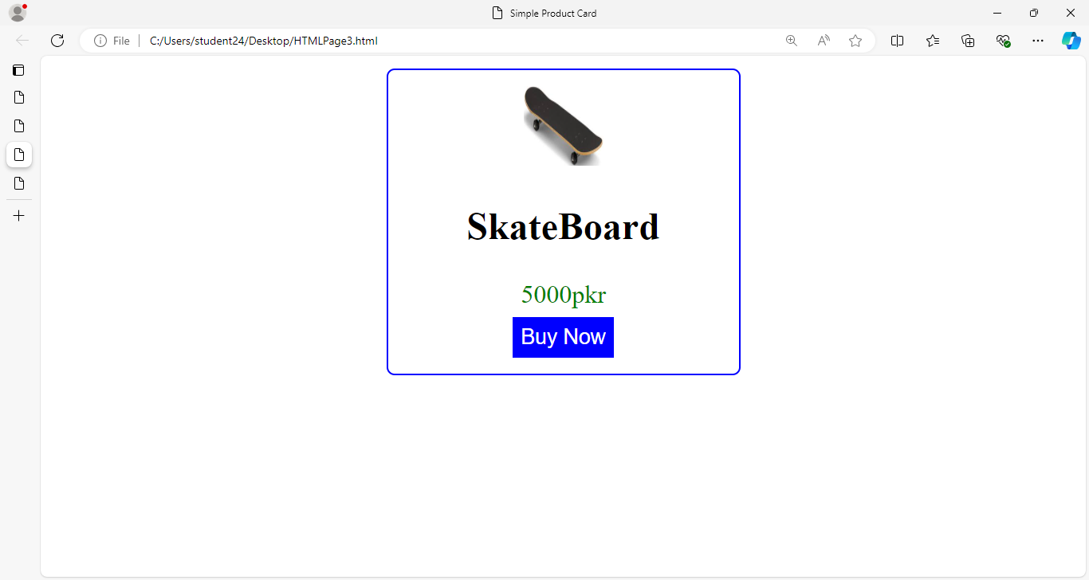

<!DOCTYPE html>

<html>

<head>

<title>Simple Product Card</title>

<style>

body {

display: flex;

justify-content: center;

background-color: white;

}

.card {

border: 1px solid blue;

border-radius: 5px;

padding: 10px;

width: 200px;

text-align: center;

background: white;

margin-top: 20px;

}

.price {

color: green;

}

.buy-button {

background: blue;

color: white;

border: none;

padding: 5px;

cursor: pointer;

}

</style>

</head>

<body>

<div class="card">

<img src="https://encrypted-tbn0.gstatic.com/images?q=tbn:ANd9GcSaU7cdpiz_dEH1XqLKRJZmlSRXdHfbeZlcTSps7MXBXmZU36GI2BOpPjPcMNI-grOMxI0&usqp=CAU"

alt="Product" height="80" width="80" />

<h2 class="title">SkateBoard</h2>

<p class="price">5000 PKR</p>

<button class="buy-button">Buy Now</button>

</div>

</body>

</html>

Question:4

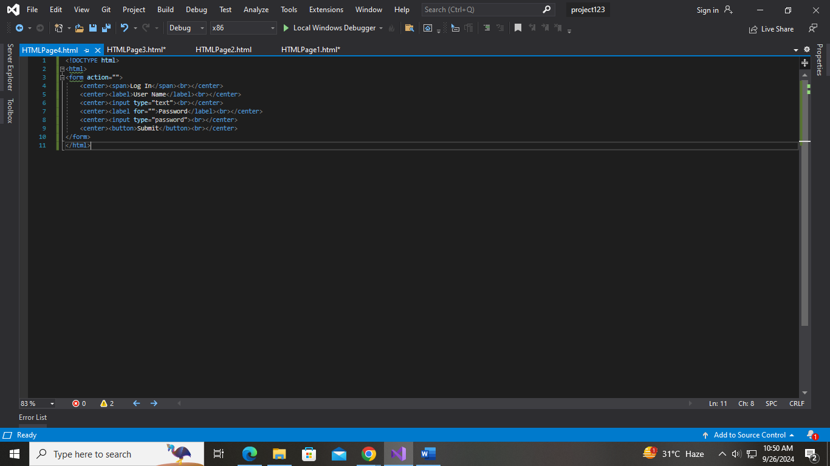

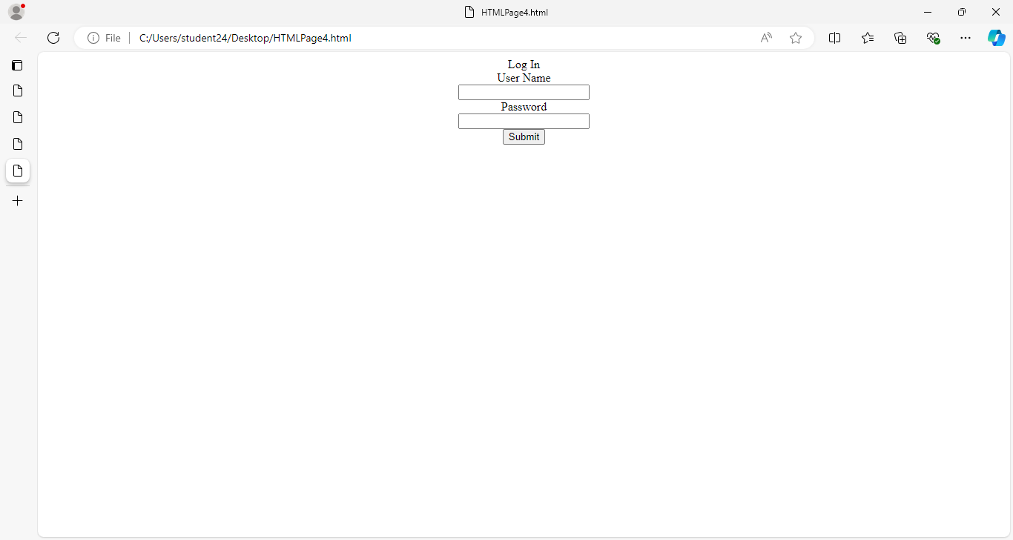

<!DOCTYPE html>

<html>

<head>

<title>Login</title>

<style>

body {

display: flex;

justify-content: center;

align-items: center;

}

form {

text-align: center;

}

</style>

</head>

<body>

<form>

<p>Log In</p>

<label>User Name</label><br>

<input type="text"><br><br>

<label>Password</label><br>

<input type="password"><br><br>

<button type="submit">Submit</button>

</form>

</body>

</html>

Question 5:

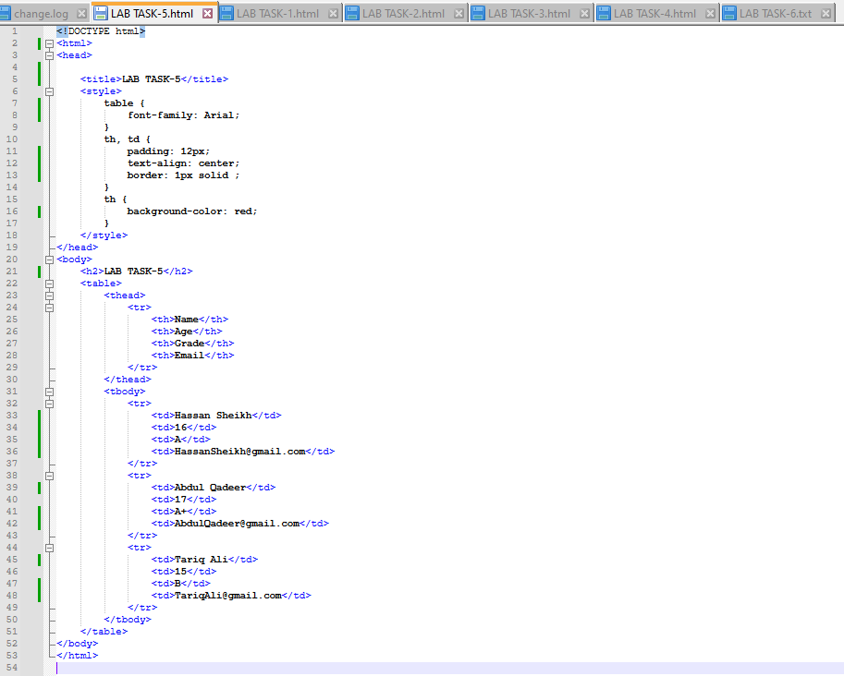

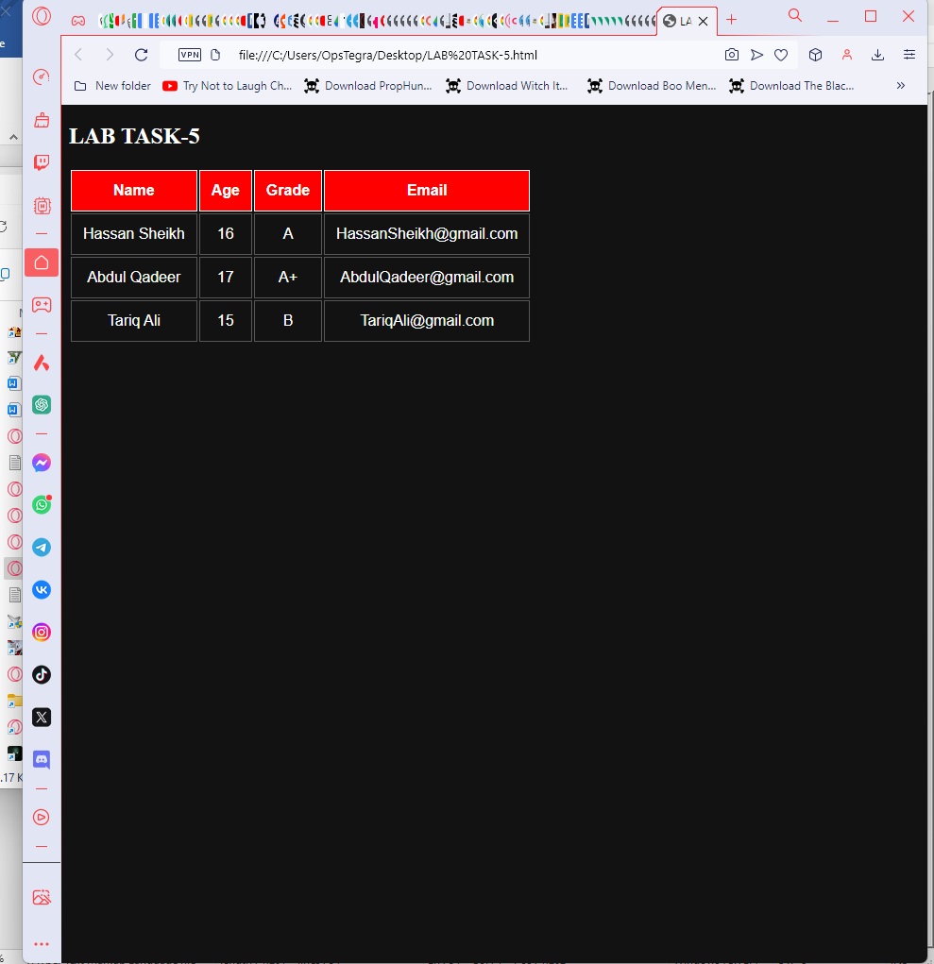

</head>

<body>

<h2>LAB TASK-5</h2>

<table>

<thead>

<tr>

<th>Name</th>

<th>Age</th>

<th>Grade</th>

<th>Email</th>

</tr>

</thead>

<tbody>

<tr>

<td>Hassan Sheikh</td>

<td>16</td>

<td>A</td>

<td>HassanSheikh@gmail.com</td>

</tr>

<tr>

<td>Abdul Qadeer</td>

<td>17</td>

<td>A+</td>

<td>AbdulQadeer@gmail.com</td>

</tr>

<tr>

<td>Tariq Ali</td>

<td>15</td>

<td>B</td>

<td>TariqAli@gmail.com</td>

</tr>

</tbody>

</table>

</body>

</html>

Question 6:

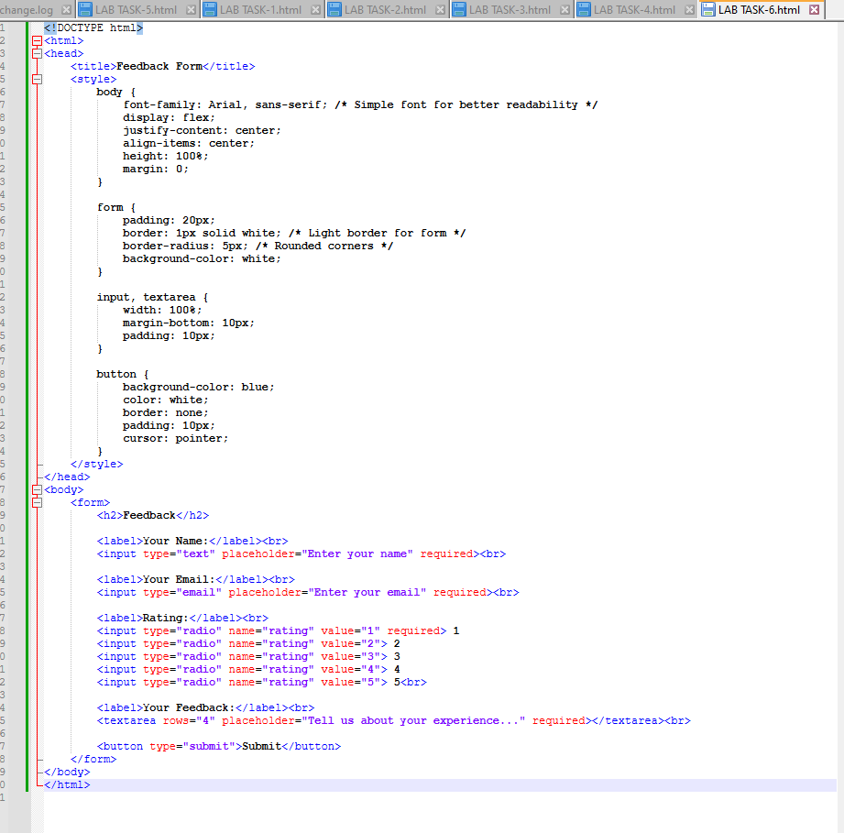

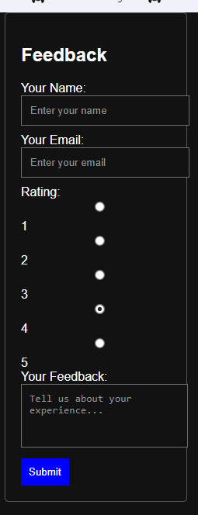

<!DOCTYPE html>

<html>

<head>

<title>Feedback Form</title>

<style>

body {

font-family: Arial, sans-serif; /* Simple font for better readability */

display: flex;

justify-content: center;

align-items: center;

height: 100%;

margin: 0;

}

form {

padding: 20px;

border: 1px solid white; /* Light border for form */

border-radius: 5px; /* Rounded corners */

background-color: white;

}

input, textarea {

width: 100%;

margin-bottom: 10px;

padding: 10px;

}

button {

background-color: blue;

color: white;

border: none;

padding: 10px;

cursor: pointer;

}

</style>

</head>

<body>

<form>

<h2>Feedback</h2>

<label>Your Name:</label><br>

<input type="text" placeholder="Enter your name" required><br>

<label>Your Email:</label><br>

<input type="email" placeholder="Enter your email" required><br>

<label>Rating:</label><br>

<input type="radio" name="rating" value="1" required> 1

<input type="radio" name="rating" value="2"> 2

<input type="radio" name="rating" value="3"> 3

<input type="radio" name="rating" value="4"> 4

<input type="radio" name="rating" value="5"> 5<br>

<label>Your Feedback:</label><br>

<textarea rows="4" placeholder="Tell us about your experience..." required></textarea><br>

<button type="submit">Submit</button>

</form>

</body>

</html>

Question :7

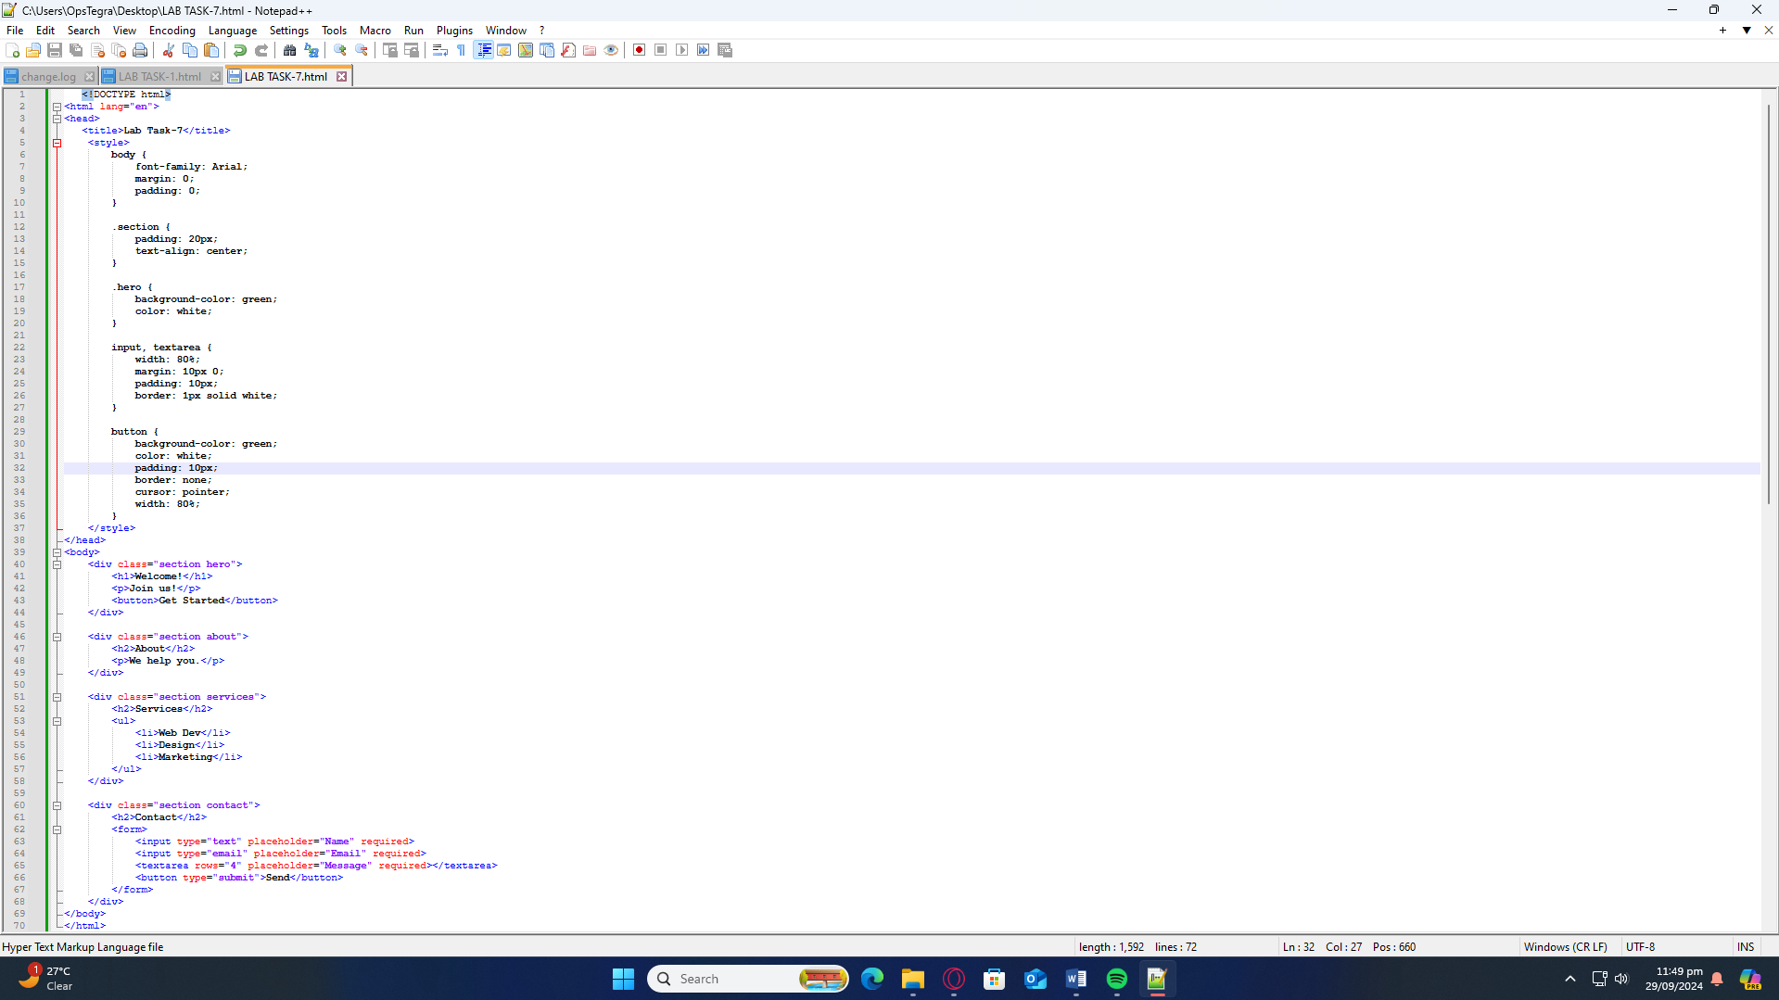

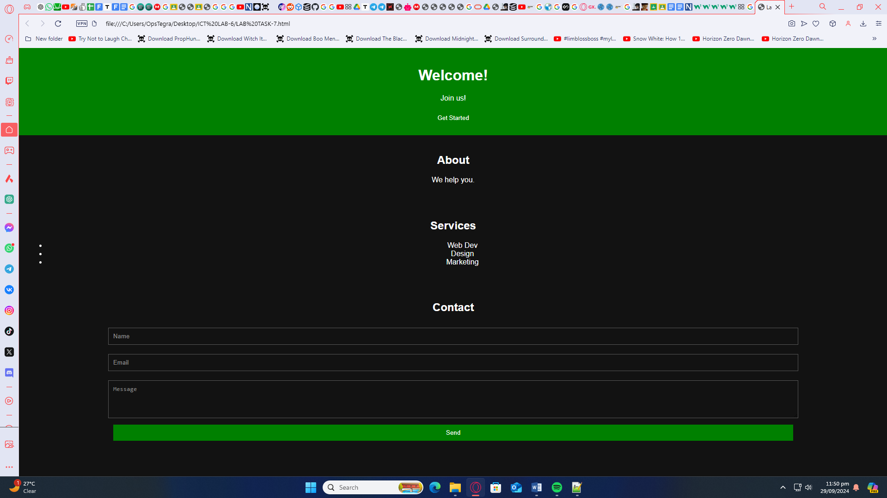

<!DOCTYPE html>

<html lang="en">

<head>

<title>Lab Task-7</title>

<style>

body {

font-family: Arial;

margin: 0;

padding: 0;

}

.section {

padding: 20px;

text-align: center;

}

.hero {

background-color: green;

color: white;

}

input, textarea {

width: 80%;

margin: 10px 0;

padding: 10px;

border: 1px solid white;

}

button {

background-color: green;

color: white;

padding: 10px;

border: none;

cursor: pointer;

width: 80%;

}

</style>

</head>

<body>

<div class="section hero">

<h1>Welcome!</h1>

<p>Join us!</p>

<button>Get Started</button>

</div>

<div class="section about">

<h2>About</h2>

<p>We help you.</p>

</div>

<div class="section services">

<h2>Services</h2>

<ul>

<li>Web Dev</li>

<li>Design</li>

<li>Marketing</li>

</ul>

</div>

<div class="section contact">

<h2>Contact</h2>

<form>

<input type="text" placeholder="Name" required>

<input type="email" placeholder="Email" required>

<textarea rows="4" placeholder="Message" required></textarea>

<button type="submit">Send</button>

</form>

</div>

</body>

</html>